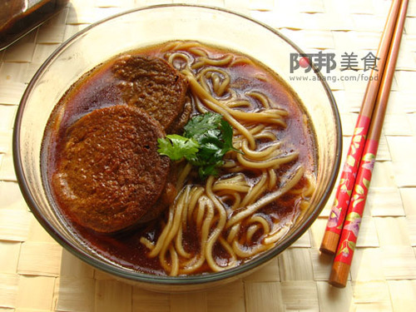
Cheap Noodle Shop Menu Translation:
- 素鸡面7元、su 4 ji 1 mian 4 qi 1 RMB 2 Vegetarian Chicken Noodle Bowl 7 RMB -Suji (素鸡) is a pressing round Yuba soy , generally referred to as vegetarian chicken or tofu round. Fragrant vegetarian chicken-fried noodles Stewed do after being called vegetarian chicken noodles , is very common in the vicinity of Shanghai, Nanjing, taste sweet , vegetarian chicken in soup strong, particularly tasty)
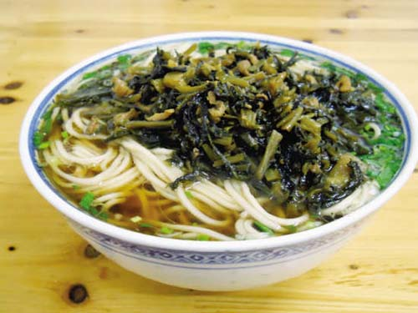
- 雪菜肉丝面 xue 3 cai 4 rou4 si 1mian 4。Pickled cabbage pork noodles, 7 RMB. Note most everything has 面 in the title because that is “mian 4” meaning noodles.

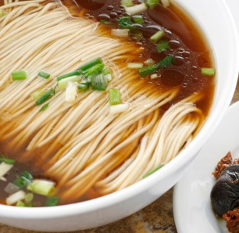

- 面巾面 mian 4 jin 1 mian 4 qi 1RMB 2 noodles 7 RMB –This is a slang term for the standard bowl of noodles, it means washcloth noodles because it looks like a washcloth made of noodles floating in the bowl.
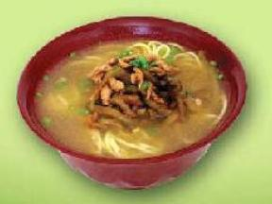
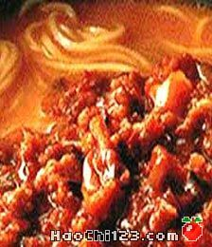
- 榨菜肉丝面8元 zha 1 cai 4 rou 4 si 1 mian 4 8 RMB Mustard Pork Noodles. These have no real mustard in them and we have no idea why they are called that. The first two characters are “mustard”.

- 川味辣酱面8元 chuan 1 wei 4 la 4 jiang 4 mian -Sichuan spicy sauce noodles 8 RMB -These spicy noodles are famous and very common in China. Pretty spicy and usually include some pork meat as well. Quite good!

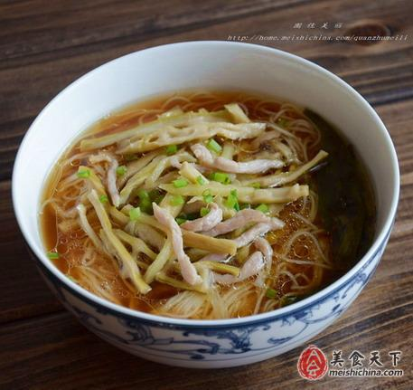
- 扁尖丝面8元 bian 3 jian 1 si 1 mian 4 - Flat tip pork noodles 8 RMB -These are also very good. If you want to appreciate just how much work goes into each of these dishes check out the recipe for this one to do in your home at:
http://home.meishichina.com/space-359939-do-blog-id-374101.html

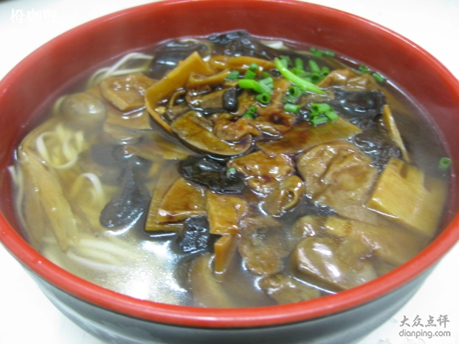
- 炒肉面8元 chao 3 rou 4 mian 4 ba 1RMB 4 Fried meat noodles eight RMB

- 素浇面8元 su 4 jiao 1mian 4 ba 1 RMB4 Plain Water Noodles 8 RMB –These usually have mushrooms and other bits of vegetables served in it. It is called Plain Water because the broth is not as dark/strong as many other soups/noodles served.

- 葱油香菇面9元 con1 you 2 xiang 1 gu 1 mian 4 jiu 3 -Onion oil with mushroom noodles 9 RMB
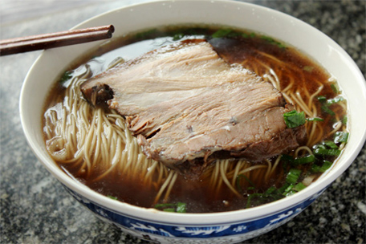
- 东吴焖肉面10元 dong 1 wu 2 men 1 rou 4 mian 4 shi 2 - Dongwu braised meat noodles 10 RMB – This is called “East Wu” stewed or braised meat noodles. It is worth noting that “Wu” is a dialect of Chinese spoken in Jiangsu and Zhejiang provinces and the city of Shanghai, hence it is a local dish to Suzhou.

- 苏式鲍鱼面11元 su 1 shi 4 bao 4 yu 2 mian 4 shi 2yi 1 - Su shi abalone noodles 11 RMB – The first two characters translate as “Soviet Style” but the first character is the same “Su” as in SuZhou, so we suspect this means it is Suzhou Style and not Soviet Style. It should be noted that “abalone” is “an edible mollusk of warm seas that has a shallow ear-shaped shell lined with mother-of-pearl and pierced with respiratory holes.” Google it, it looks like a clam type thing.
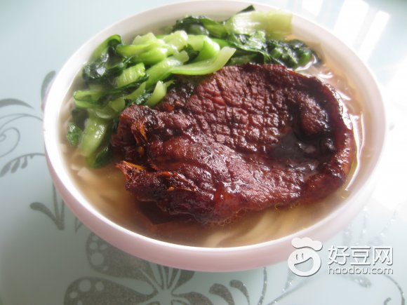
- 红烧大排面11元 hong 2 shao 1 da 4 pai2 mian 4 Braise in soy sauce big meat 11 RMB -Hong Shao means “braised” and Da Pai means large flat thing but refers to a large flat piece of braised pork in your noodles in this case. Try it, but ask for a less fatty piece of meat if you can, these can be very good or very bad depending on the cut of meat you get. We have not tried this dish at this place yet.
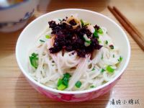

- 葱拌辣酱面11元 cong1 ban 4 la4 jiang 4 mian 4 Onion stir sauce noodles / Scallion noodles sauce surface 11 RMB

- 桂花鸭炖面12元 gui4 hua 1 ya1 dun4 mian 4 shi2 er 4 - Osmanthus duck stewed noodles 12 RMB –This is noodles with the famous Duck flavored with Osmanthus in it. Osmanthus is a sweet clover found in Asia that is most common when cooking duck. Note the character “鸭” which means duck in Chinese.

- 汤肚尖面12远 non 2 tang 1 du 4 jian 1 mian 4 Soup pot belly, pointed face 12 RMB –Now we are getting into some strange fare, in our opinion. This is tripe soup, it is made from the intestines and stomach of the pig. You are welcome to try it, but we’re skipping this dish completely.
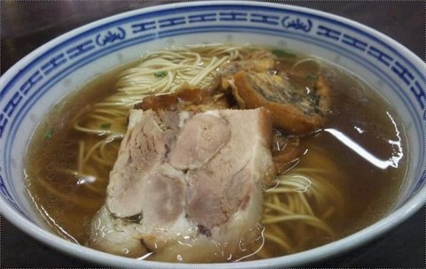
- 东吴焖蹄面12元 dong1 wu2 men1 ti2 mian4 Dongwu braised shoe surface 12 RMB (see #10 for a discussion on Dong Wu, it is the name of local noodles in Suzhou. This is the Hoof or Shoe meat, meaning it comes from the foot of the pig. Don’t freak out, it isn’t bad tasting. It is a strange piece of meat and deserved to have a photo, see right.

- 牛肉面16元 niu2 rou4 mian4 Beef noodles, 16 RMB. If you don’t know that first character in this item yet then learn it. IT is “niu2” meaning BEEF. It will always be more expensive than pork or duck or chicken because beef is scarce in China. This is beef noodles and it is good.

- 东吴焖鸭面15元 dong1 wu2 men1 ya2 mian4 Dongwu braised duck 15 RMB. This is the DongWu (see #10) duck noodles

- 鸡汁大排面13元 ji1 zhi 1 da4 pai2 mian4 13 RMB big row of chicken juice. This is about the same thing as #12 but with Chicken instead of pork for the “da pai”, the big piece of chicken on your noodles.
- 葱拌焖肉面13元 cong1 ban4 men1 rou4 mian4 13 RMB onion with braised meat noodles

END OF THE FIRST LINE on the menu!
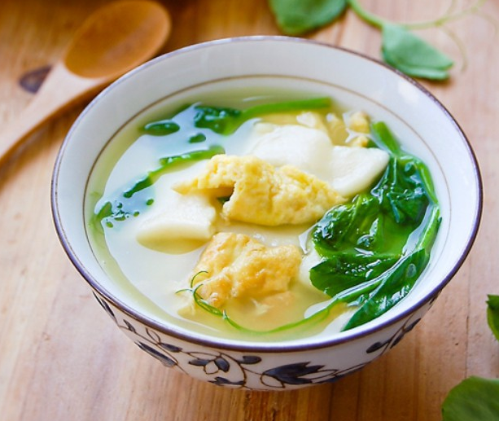
- 面尖鸡蛋面9元 mian4 jian1 ji1 dan4 mian4 Egg noodles surface tip 9 RMB

- 炒肉鸡蛋面10元 chao3 rou4 ji1 dan4 mian4 shi2 RMB2 Fried meat, egg noodles ten RMB –This is meat + egg in the noodles.

- 素浇鸡蛋面10元 su4 jiao1 ji1 dan4 mian4 shi2 RMB2 Sprinkle egg noodles 10 RMB

- 炒肉青菜面10元 chao3 rou4 qing1 cai4 mian4 shi2RMB2 Fried meat vegetables noodles 10 RMB

- 焖肉青菜面12元 men1 rou4 qing1 cai4 mian4 Braised meat vegetables noodles 12 RMB

- 焖肉鸡蛋面12元 men1 rou4 ji1 dan4 mian4 Braised meat egg noodles 12 RMB

- 鲍鱼鸡蛋面13元 bao4 yu2 ji1 dan4 mian4 Abalone 13 RMB egg noodles (remember Abalone from #11 above)

- 大排鸡蛋面13元 da4 pai2 ji1 dan4 mian4 Big meat (pork) + Egg Noodles 13 RMB

- 炒肉面巾面14元 chao3 rou4 mian4 jin1 mian4 Fried meat in the “washcloth” noodles from #3- 14 RMB

- 焖蹄青菜面14元 men1 ti2 qing1 cai4 mian4 Braised hoof vegetables 14 RMB

- 雪菜焖肉面16元 xue3 cai4 men1 rou4 mian4 Pickled cabbage stewed meat noodles 16 RMB

- 焖肉面巾面16元 men1 rou4 mian4 jin1 mian4 Braised meat face towel 16 RMB –Meat from #16 + washcloth noodles from #3
- 素浇焖肉面17元 su4 jiao1 men1 rou4 mian4 Plain water the braised meat noodles 16 RMB, another combination of noodles with a former dish, Plain Water and Su Style noodles.
- 雪菜辣酱焖肉面17元 la4 jiang4 da4 pai2 mian4 17 RMB sauce stewing meat noodles
- 辣酱焖肉面17元 la4 jiang4 da4 pai2 mian4 17 RMB sauce stewing meat noodles

- 炒肉鲍鱼面18元 chao3 rou4 bao4 yu2 mian4 Fried meat abalone (Same Abalone as #11) 18 RMB

- 牛肉青菜面18元 niu2 rou4 qing1 cai4 mian4 mian4 Beef vegetables noodles 18 RMB –This is going to be pretty good, it is beef + veggies + noodles.

- 鲍鱼素浇面18元 bao4 yu2 su4 jiao1 Abalone topping 18 RMB

- 牛肉鸡蛋面18元 niu2 rou4 ji1 dan4 mian4 Egg + Beef in noodles 18 RMB
- 大排香菇面19元 da4 pai2 xiang1 gu1 mian4 Big mushroom surface 19 RMB

- 鲍鱼焖肉面20元 bao4 yu2 men1 rou4 mian4 Abalone stewed meat noodles 20 RMB

- 大排鲍鱼面21元 da4 pai2 bao4 yu2 mian4 Big Meat abalone noodles 21 RMB

- 葱拌牛肉面19元 cong1 ban4 niu2 rou4 mian4 Onion stir beef noodles, 19 RMB

End of 2nd Row!
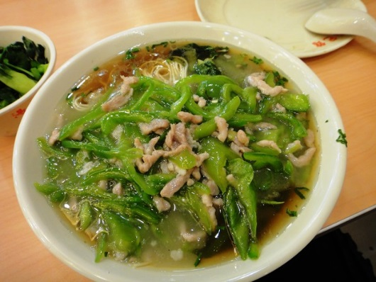
- 青椒肉丝面10元 qing1 jiao1 rou4 si1 mian4 Green peppers + Pork noodles 10 RMB -These are quite good if you like green peppers!

- 清炒猪肝面12元 qing1 chao3 zhu1 gan1 mian4 Stir-fried pork liver noodles 12 RMB –Pork Liver? Yeah I stay away from this one. If you don’t know the character for liver, learn it and avoid it like we do! That is 肝
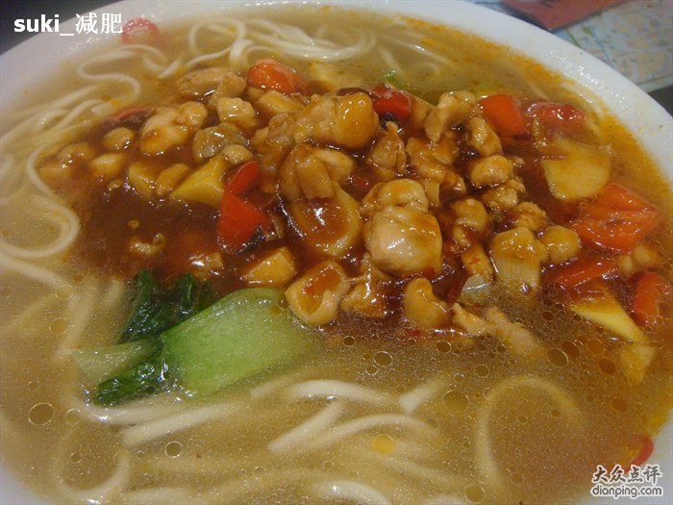
- 清炒肉丝面12元 qing1 chao3 rou4 si1 mian4 Fried meat noodles 12 RMB -Sounds good but we haven’t tried this one!

- 辣子鸡丁面13元 la4 zi3 ji1 dian1 mian4 Chicken enchiladas 13 RMB –Don’t get too excited, this is NOT chicken enchilada, a better translation is probably spice chicken noodles. I believe it is basically Kung Pao Chicken in your noodle dish, but we need to try it to see. It should look like this:

- 大肠面15元 da4 chang2 mian4 Large Intestine Noodles 15 RMB –Yeah, this is one I will never touch. Not a big fan of the large intestine of the pig, but go for it if you want!

- 葱拌猪肝面15元 cong1 ban4 zhu1 gan1 mian4 -Onion mix pork liver 15 RMB –Yeah, I’ll avoid this one!

- 虾仁面18元 xia1 ren2 mian4 Shrimp noodles 18 RMB Now we are talking! Shrimp noodles! Yum! If you don’t know shrimp, memorize it: 虾
- 腰花面16元 yao1 hua1 mian4 Kidney Noodles 16 RMB –I hate Kidney, you’re on your own with this one
- 鳝糊面16元 shan4 hu2 mian4 Eel covering 16 RMB -Yeah, the word Eel means I won’t probably ever try this one.
- 葱拌鸡丁面16元 cong1 ban4 ji1 din1 mian4 Onions with chicken noodles 16 RMB Sounds great!
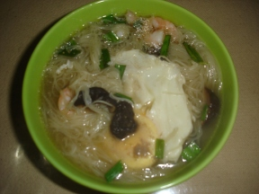
- 三鲜面16元 san1 cian1 mian4 Three fresh side 16 RMB Shrimp, Egg and Mushrooms!

- 虾仁鸡蛋面20元 xia1 ren2 ji1 dan4 mian4 Shrimp egg noodles is 20 RMB -YUM!

- 葱拌虾仁面21元 cong1 ban4 xia1 ren2 mian4 Onion mix shrimp face 21 RMB

- 鳝糊猪肚面27元 shan4 hu2 zhu1 du3 mian4 Eel paste pork stomach 27 RMB Oh, Pork Stomach and Eel with Pork Paste? What’s not to like? No thanks!

- 鳝糊肉丝面27元 shan4 hu2 rou4 si1 mian4 Eel paste paper 27 RMB Eel? Not for me!
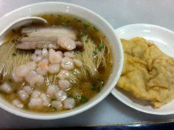
- 虾仁焖肉面27元 xia1 ren2 men1 rou4 mian4 Shrimp stewed meat noodles 27 RMB… YUM! (See photo to the right)

- 虾仁鲍鱼面28元 xia1 ren2 bao4 yu2 mian4 Shrimp stewed meat noodles 27 RMB
- 虾仁大排面28元 xia1 ren2 da4 pai2 mian4 Shrimp big meat noodles of 28 RMB

- 虾仁肉丝面29元 xia1 ren2 rou4 si1 mian4 Fried shrimps meat pieces noodles 29 RMB

- 鳝糊虾仁面33元 shan4 hu2 xia1 ren2 mian4 Eel paste shrimp noodles 33RMB –Not for me!
- 虾仁腰花面33元 xia1 ren2 yao1 hua1 mian4 Shrimp kidneys Noodles 33RMB

Last Row
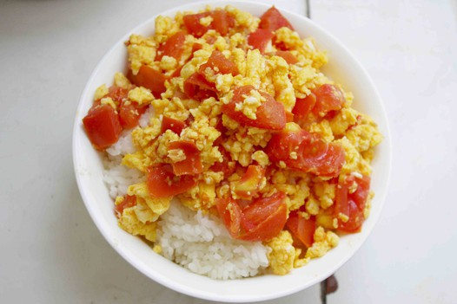
- 番茄炒蛋饭12元 fan1 qie4 chao3 dan4 fan4 Tomato scrambled egg rice 12 RMB -I LOVE THIS DISH, One of my favorites!

- 扣肉豆腐饭12元 kou4 rou4 dou4 fu3 fan4 Braised pork ToFu Rice 12 RMB

- 麻婆豆腐饭12元 ma2 po2 dou4 fu3 fan4 The bean curd rice 12 RMB
- 海带肉丝饭12元 hai 3 dai4 rou4 si1 fan4 Kelp pork rice 12 RMB
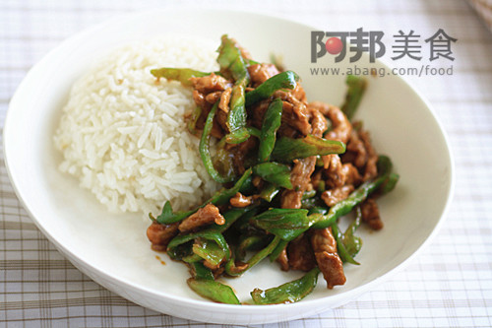
- 青椒肉丝饭14元 qing1 jiao1 rou4 di1 fan4 Green pepper pork rice 14RMB Looks good (see left)

- 咸泡饭14元 xian2 pao4 fan4 Salty rice in soup 14 RMB

- 菌菇肉丝饭15元 jun1 gu1 rou4 si1 fan4 The fungus mushrooms pork rice 15 RMB

- 浓汤肚尖饭15元 non2 tang1 jian1 fan 4 Soup pot belly pointed rice 15 RMB -Beware, this is intestines again!
- 鱼香肉丝饭15元 yu2 xiang1 rou4si1 fan4 Braised pork rice 15 RMB
- 青椒猪肝饭15元 qing1 jiao1 zhu1 gan1 fan4 Green pepper pork liver rice 15 RMB Pork Liver? Yuck!
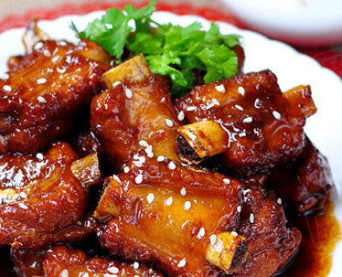
- 糖醋排骨饭15元 tang2 cu4 pai2 gu3 fan4 Sweet and sour spareribs rice 15 RMB See photo to the right. These are quite good and come about ½ sweet and sour ribs and the other half of the plate as white rice.

- 青椒肚丝饭16元 qing1 jiao1 rou4 du4 si1 fan4 Green pepper Tripe rice 16 RMB –Yes this is Tripe (intestines)

- 虾仁滑蛋饭16元 xia1 ren2 hua2 dan4 fan4 Shrimp egg rice 16 RMB –Probably pretty yummy!

- 洋葱大肠饭18元 yang2 cong1 da4 chang2 fan4 Large Intestine onion rice 18 RMB –Gross!
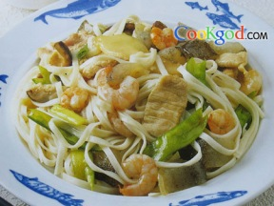
- 三鲜炒面15元 san1 xian1 chao3 mian4 Three fresh Fried noodles 15 RMB –This is extremely good, triple ingredient fried noodles, always good! Try it!

- 青菜肉丝炒面12元 qing1 cai4 rou4 si1 chao3 mian4 Green vegetables pork Fried noodles 12 RMB -Also very good! Worth eating!
- 咸肉菜饭12元 xian2 rou4 cai4 fan4 Bacon rice dish 12 RMB -If the bacon is lean this is great, if it is fatty it can be questionable.

- 肉丝炒饭12元、rou4 si1 chao3 fan4 Pork Fried rice with 12 RMB –Always good!

